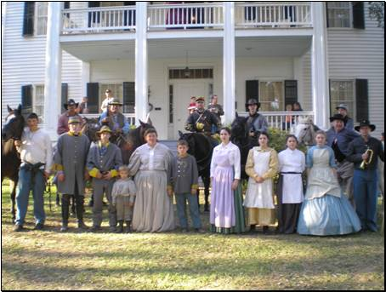
Fire, Sword ,& Halter

Volume X Series V
News Letter of the Third Regiment of Texas Cavalry Reenactors and Venture Crew 1861, BSA

24 September 2007

Commanders Corner
This fall has had a rough start for me and our fist two events I have to bow out from. I thank you for your prayers on my mother’s behalf and they have been answered as it was benign. I have not received a report on Hondo from the Corporal yet but as soon as I do I will post it in the newsletter. I do know that members of the 3rd did make it safely to Hondo and I know they did well representing our unit. SFASU will be sending me to Baltimore in October to the NACADA conference, which coincides with the dates for the Raid on Camp Ford. Gordon Lentz will serve as bvt. Sgt. And take charge in my absence with the help of Cpl. McDonald. They will also conduct an election of a new Sergeant to replace Trooper Emshoff; Sean Cox is nominated for the position and is well qualified to take over the leadership of the dismounted branch.
I am sending this addition out a little early this month due to the Fall meeting of the East Texas Historical Association (ETHA). The Association hosts its fall meeting every year in Nacogdoches at the Fredonia Hotel. The conference begins each year with the Lale Lecture hosted in the Baker Pattillo Student Center Grand Ballroom on the beautiful campus of Stephen F. Austin State University. This year’s speaker will be William Seale, Ph.D.; Dr. Seale has been involved in the restoration of historic buildings to include state capitals and the George C. Marshall House. This should prove to be an interesting speaker and will start promptly at 7:30 PM Thursday night September 27. Persons interested in the ETHA can go to the website at http://www.easttexashistorical.org. Hope to see you there,
Fall Meeting of the East Texas Historical Association
September 27-28
Fredonia Hotel
Nacogdoches,Texas
http://www.easttexashistorical.org
Maj. Dyson V. Nickle, Jr.

"There is no more dangerous experiment than that of undertaking to be
one thing before a man's face and another behind his back."
-Robert E. Lee
Event Schedule
October 19-21 Battle of Jones Meadow, Tyler, Texas
Nov. 15-18 Plantation Liendo 3rd Texas’ Birthday Party
Feb. 1-3 Madisonville School Day on Friday
April, Pleasant Hill and Jackson Cross Roads. Pleasant Hill should be April 4-6. Still waiting on information from Division on Jackson Cross Roads.

These are the events chosen in our scheduled meeting. All events are max efforts on the part of the 3rd Texas Cavalry. Members are always welcome to participate in other events but if you must choose one over another please make every effort to support the group. If you have any questions please contact Maj. Nickle

October 7 is the blessing of the animals at St. Cyprian’s in Lufkin. Breakfast is at 8:15 then we can ride around in the creek. It has been great fun in past years.

School of the Solder

(William Gilham)

Deployment of Skirmishers
263. (con’t from last month) Once deployed as skirmishers and At the command march, the left group of four men, conducted by the fourth sergeant, will direct itself to the point indicated; all the other groups of four throwing forward briskly the left shoulder (as in the right oblique), will move diagonally to the front at the double quick time, so as to gain to the right a space of twenty paces, which shall be the distance between each group and that immediately on its left. Once each set has arrived on line with the set to its left it will conform to the gait and direction of the first. The right guide will arrive with the last group. (That is to say that the Fourth Sergeant will take the first set forward to mark the left of the Skirmish line and that each successive set will guide on the set to its left. The members of each set must support the members of that set and each set will in turn support the sets to their right and left. If a set should wonder too far to the right they could endanger those set to their left.) 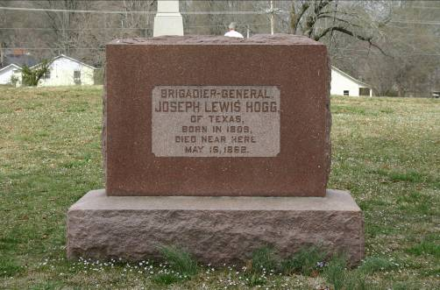
The left guide having reached the point where the left of the line should rest, the captain will command the skirmishers to halt (this may be done by bugle); the men composing each group of fours will then immediately deploy at five paces from each other, and to the right and left and left of the front rank of men of the even file in each group, the rear rank men placing themselves on the left of their file leaders. If any groups be not in line at the command halt, they will move up rapidly, conforming to what has just been prescribed.

BARN RULES!!!!!
(unknown author)

1. I am human. You are horse. What I say goes. Please take that into consideration when you are standing on my foot.
2. Spilled grain is not "fair game," especially when it is spilled in another horses stall. It still belongs to that particular horse. You have no reason to go in and eat it.
3. Poop does not need to be hidden. I clean your stall every day. I will find it. Do not hide it.
4. I do not need your help when I clean the barn, nor do I need your supervision, or even your presence. I have been cleaning the barn and stalls ever since you lived here. I know what I am doing. Standing at the door staring at me, will not make me clean faster.
5. There is no need to go into the barn and help yourself to the feed.
Meals are given at specific times of the day. There is a feed schedule. You know the schedule. I know you know the schedule. You know that I know that you know the schedule. There is no need to help yourself.
6. Water buckets are not toys. Neither is the gate, pitchfork, wheel barrow, whatever is in the
dwheel barrow, fence, or the occasional dog.
7. The wheel barrow is there for a reason. Please do not try to move it while I am cleaning your stall. 8. Just because I go into the barn doesn't mean you automatically get food. There is other stuff in the barn. Stuff you don't want. Like wormer and fly spray.
9. Sheath cleaning will NOT be enjoyed...by anyone. ???
10. Water travels through the hose. If you are thirsty, do not stand on the hose. The water buckets will fill much faster.
11. Not everything has to be high drama. None of the following things will kill you: fly spray, plastic bags, balloons, hoses, chipmunks and other small rodents, or bright blue tarps.
12. Although I understand the need for you to go to the bathroom, it is not necessary to hold it in all day until the moment I finish cleaning your stall and put away the wheel barrow.
13. Accidents happen. However, I'm not altogether sure you're not trying to kill yourself. Next time you decide to impale yourself on some sort of object, please try to do it when it's not hailing, midnight, the weekend, or Christmas.
14. While I appreciate your need to be clean, pooping in your water bucket does not make my job easier, and it deprives you of water. Please find a new spot.
15. Whinnying as loudly as you can in my face does not make me feed you any faster
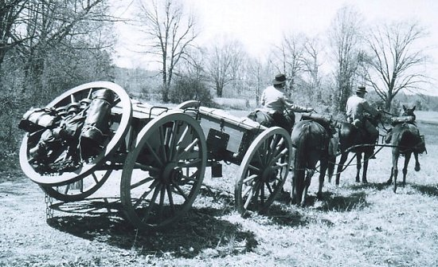
Attending Events
Ladies and Gentlemen: It is important to let me know what events you plan to attend so I can register us for those events. Event planners are trying to get amenities for us but if they do not know who is coming they do not know how much to get. Too few chemical toilets or not enough firewood are two important problems I can think of right off. Please let me know as soon as possible, I like to try and register us 3-4 months before an event and some events request that information even earlier than that. I have a list that I use with everyone in the unit on it, it is a standardized form similar in use at most events that I just send in. By that token it assumes everyone is going, that said it is nice to receive an RSVP for every event, which includes a confirmation or regret. It would be ever so helpful if everyone would comply.
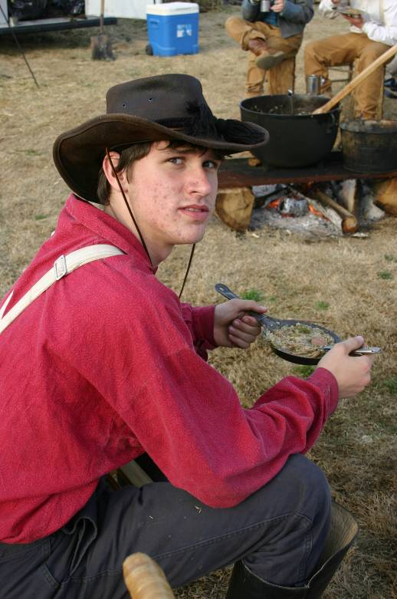
Kenny W. Shiloh ‘07
“Don’t ask, just eat.”

History of the East Texas Historical Association
The first East Texas Historical Association began when W. F. Garner, chairman of the Department of History at Stephen F. Austin State Teachers College, now University, invited members of his faculty and of the faculties at Sam Houston State Teachers College and East Texas State Teachers College to form an organization to promote the study of East Texas history. The group met in Nacogdoches on April 29-30, 1927, and annually thereafter on college campuses in Huntsville, Commerce, and Nacogdoches until disbanded because of the Depression in 1932. An annual issue of papers read at the meetings was also published.
In 1962 a successor East Texas Historical Association came into being as a result of the work of Dr. Ralph W. Steen and Dr. C. K. Chamberlain, president and History Department chair at Stephen F. Austin State College, and attorneys F. I. Tucker of Nacogdoches and F. Lee Lawrence of Tyler. Lay and professional historians in East Texas received invitations to a meeting held on the SFA campus in Nacogdoches on September 29, 1962. They wrote a new constitution (revised in 1981), calling for an annual meeting each Fall in Nacogdoches and a Spring meeting elsewhere in East Texas; the publication of a semi-annual publication, the East Texas Historical Journal; and the collection and deposit of archival material in the library at Stephen F. Austin State College. F. Lee Lawrence served as the Association's first president, and Dr. C.K. Chamberlain became editor of the journal, a post he held until 1971. Because charter membership was left open for many months, 425 charter members are claimed. The practice of alternating lay and professional historians as officers was instituted, and continues. In addition to a president, first and second vice presidents, and a secretary-treasurer, nine additional members serve alternating, three-year terms on the Board of Directors, and SFASU appoints two ex-officio members.
Chamberlain retired as editor in 1971 and was succeeded by Archie P. McDonald, who serves as Executive Director, a position created in 1979, and editor of the Association's journal and other publications. The Association is housed on the campus of Stephen F. Austin State University in Nacogdoches, and continues to publish two issues of its journal annually. Membership and attendance at meetings declined late in the 1960s, but has rebounded. Membership today remains steady at about 600 in all categories and registrations at meetings varies from 150 to 175, depending upon the location of the Spring meeting.
Since 1971 the Association has established new programs to encourage the study of East Texas history and to honor those who do so. For example, the C. K. Chamberlain Award honors the article judged (by a panel of peers) the best to appear in the East Texas Historical Journal within a year; a constitutional limit of twenty-five fellows are honored for writings on the history of East Texas; the Ralph W. Steen Award honors those who have served the Association through activities primarily other than writing; the Lucille Terry Historical Preservation Award, also sponsored by the Texas Forestry Museum, honors outstanding works of historical preservation; and the Ottis Lock Endowment Awards honors outstanding teaching, the best book on East Texas each year, and research grants for those who study East Texas historical topics. And in 2000, Bob and Doris Bowman of Lufkin presented the inaugural Best of East Texas Award to Bob Murphey of Nacogdoches.
The Association inaugurated the Georgiana and Max Lale Lectures in 1997. Previous lecturers include T.R. Fehrenbach, James I. Robertson, Jr., Bill Moyers, William C. "Jack" Davis, Frank Williams, Bernard Weisberger, and James Olson. The Lale Lecturer for 2004 was Charles Wilson. The Lale Lecturer for 2005 was David Grubin, and the Lale Lecturer for 2006 was Jeff Guinn.
From the Association website http://www.easttexashistorical.org/about/history.html

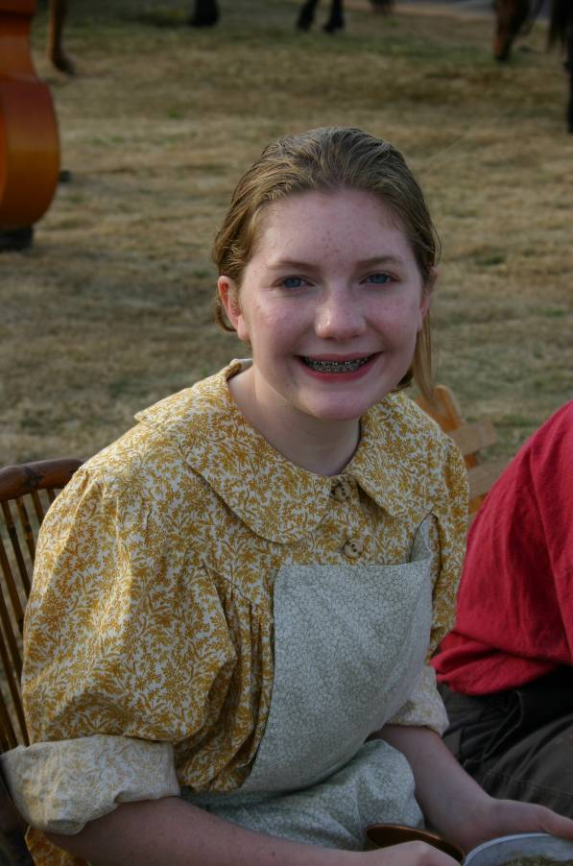Ashley M. Shiloh ‘07
Look, she’s eating it.
The First Texas Legion
The first Texas Legion was formed to consolidated smaller Texas Cavalry units and combines their forces into a viable unit for the Shiloh ’07 event. Its success there has led to the founders to continue these efforts to provide a consistent command structure. The next Legion event will be Plantation Leindo. I hope everyone makes every effort to make this one. I plan to be on site Thursday, school day at this one is great, See ya there!
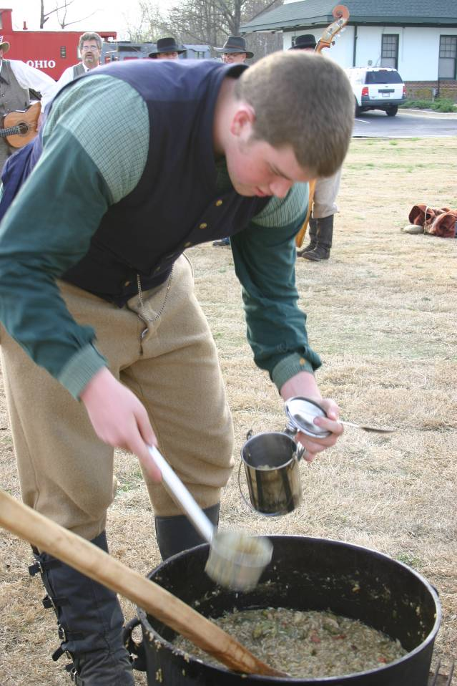
Josh E., Shiloh ‘07
Hum, he’s getting more.

Call for articles

As a new year begins and our activities are picking up please forward stories of your adventures for me to publish in our (your) newsletter. As humble as it is, it is a publication and you can include such writings on applications and resumes. 300 to 600 words are about par, please keep them under 1000 or contact me first.

"The duty is ours, the consequences are God's"
- Gen. Thomas "Stonewall" Jackson
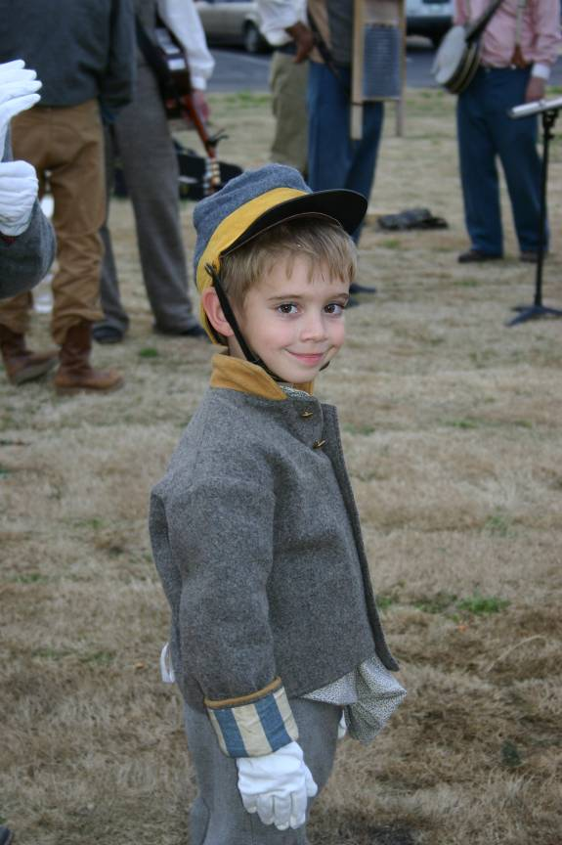
Oliver N., Shiloh ‘07
Did I hear someone say dance?

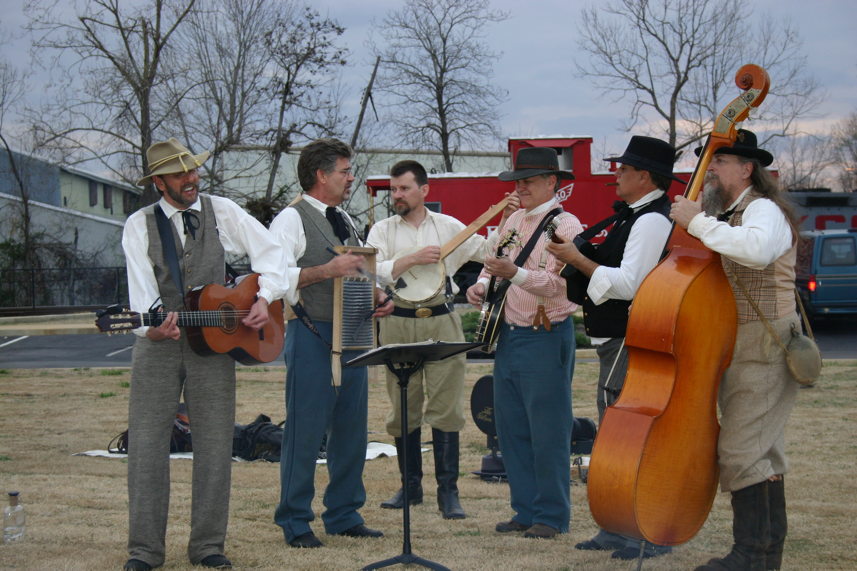
Randy McDonald on his banjo, Shiloh ‘07
Where did Ashley go?
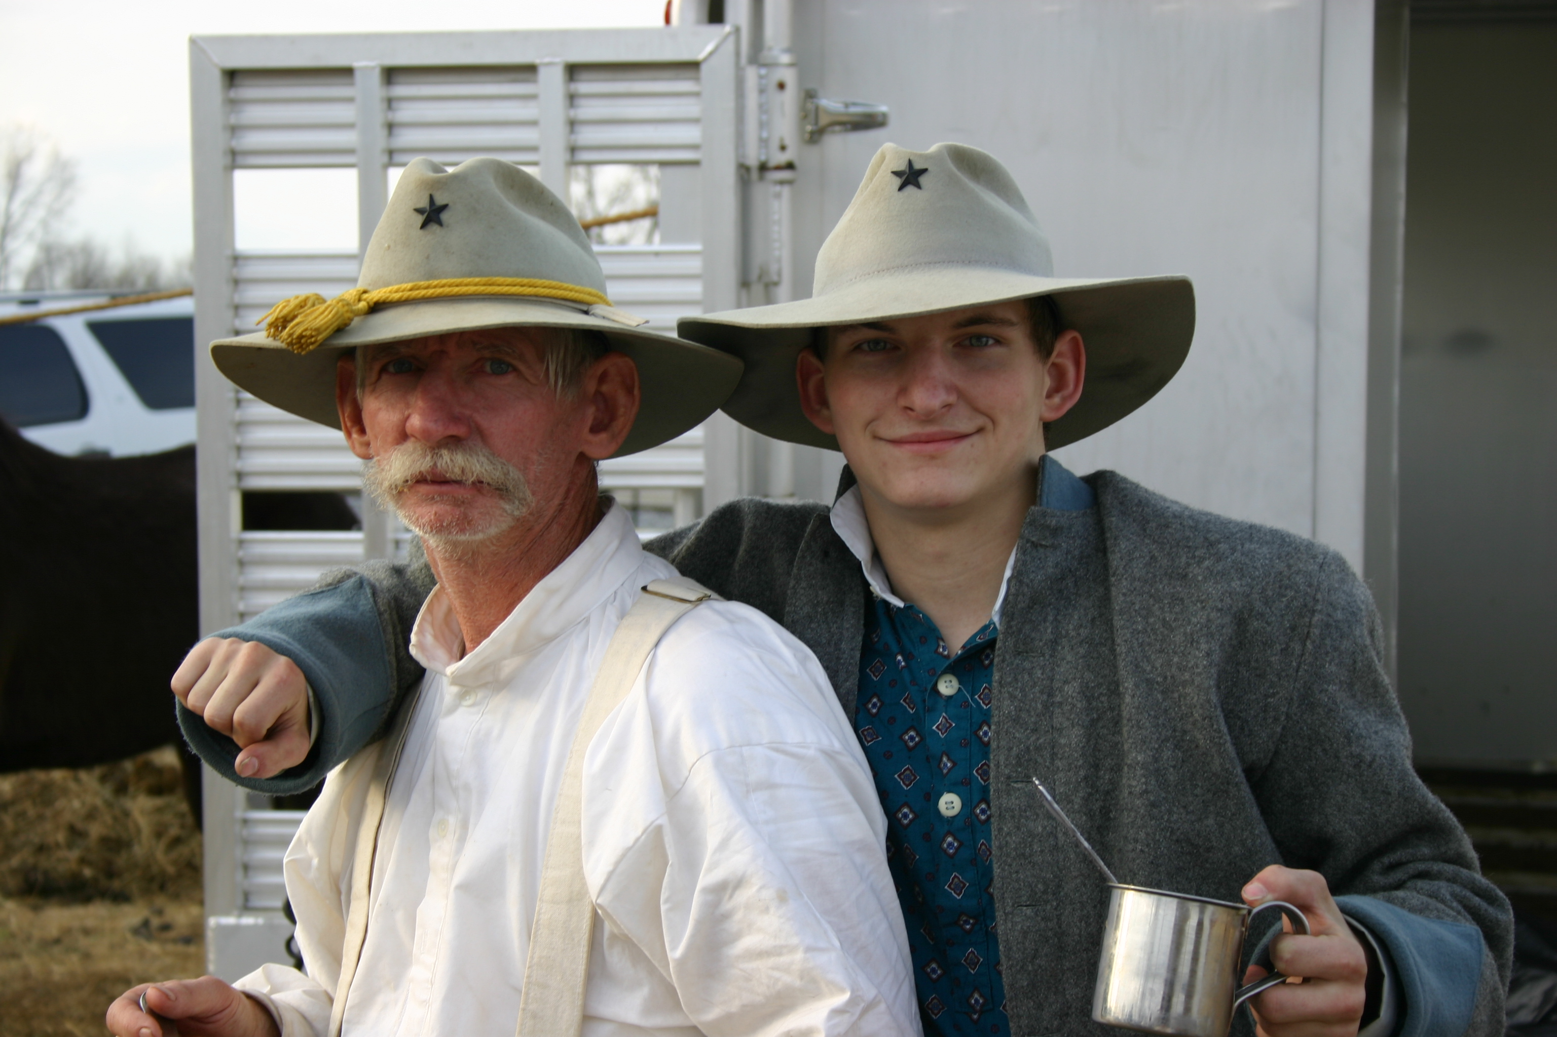
Fred and Jeff Athey

We ate it.

